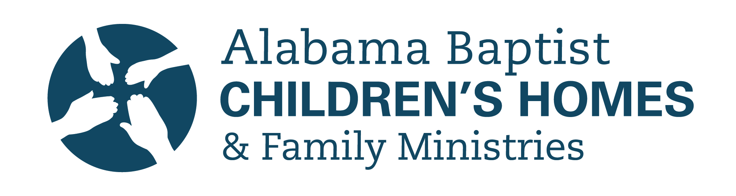
Alabama Baptist Children’s Homes & Family Ministries (ABCH)
2019 Report

Our campuses throughout the state are built and sustained with hope, healing, and safety in mind. When a child comes to one of these campus homes, we want to provide them a space where they can experience the childhoods they deserve and so often long for—one without strife or worry; one that is full of security, comfort, safety, innocence, love, and laughter.

Ashley was once one of those children. Having lived with an alcoholic dad who was often absent, she had to learn to care and provide for herself. When she arrived at our Decatur campus though, she no longer had to worry about whether or not her needs would be met. She felt safe and secure; free to, “be a kid and be a teenager.” It was also in our care that Ashley experienced, for the first time, nightly devotionals and conversations around the dinner table about their days. She knew whenever she had a family of her own, these were some of the things she wanted to do with them too.

As you may know, we serve hundreds of children like Ashley everyday through seven locations around the state, four of which have campus homes that provide both short and/or long-term care. These homes are in Decatur, Dothan, Oxford, and Mobile. One of our most exciting projects this year has been the construction of our newest home for children in Decatur, the Ensor Shelter Care Home and a second multi-purpose home, to be completed later this year. We've served children in Decatur through one Shelter Care home for many years now, but unfortunately, we have often had to turn children away for lack of available rooms. Because of your generosity, we now have an opportunity to change that, and in turn, change even more lives for God's good and glory, as these kids are lovingly welcomed into a safe and Godly home in their time of deep crisis. In addition to these new homes scheduled to open later this year, we’re excited to share that in 2018, we cared for over 4,500 people across all areas of ministry, serving 393 in our Foster Care homes, 176 in our Campus and Shelter Care homes, and 3,767 through our counseling services! We also praise the Lord for 17 professions of faith in 2018, 85 new homes licensed for foster care, 26 adoptions, and 124 reunifications to family members!

Ashley’s life was forever changed by the care and support she received while with us, and we are grateful the Lord has allowed us all to be a part of her story. Because of support from faithful donors like you, Ashley was able to go to and complete college debt-free and works as an enrollment advisor at Athens State University. She has been married now for five years and is mom to one-year-old son, Henry. Ashley’s heart is to help other children in the same ways she was helped through your Baptist Children’s Homes.

We are often reminded of God’s goodness in all that He is doing in the hearts and lives of those in our care. Sometimes we see the impact now, and sometimes we see it years from now—and either way, we know He is at work! Thank you for your partnership in this Kingdom work as you come alongside us in our mission to protect, nurture, and restore children and families through Christ-centered services. Thank you for the life-changing differences you are making now and in to eternity.

