4 Ways to Do Bible Drill
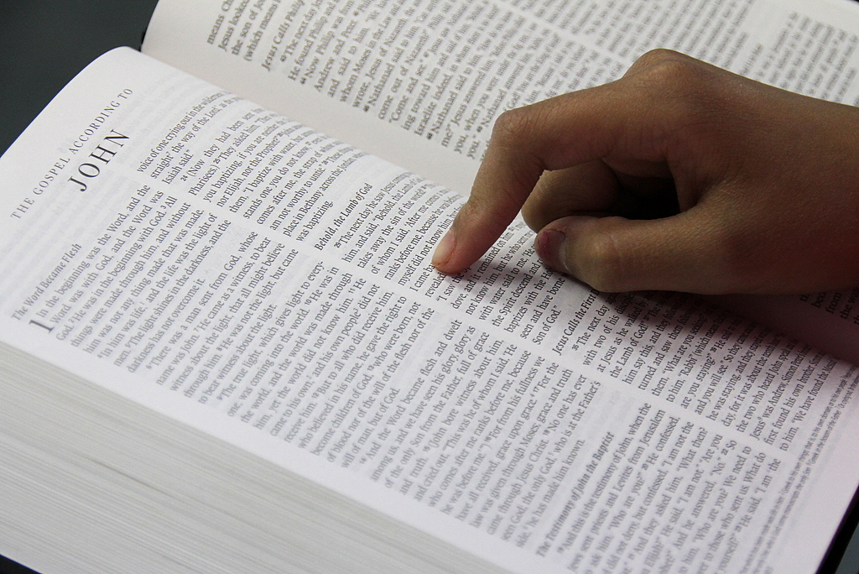
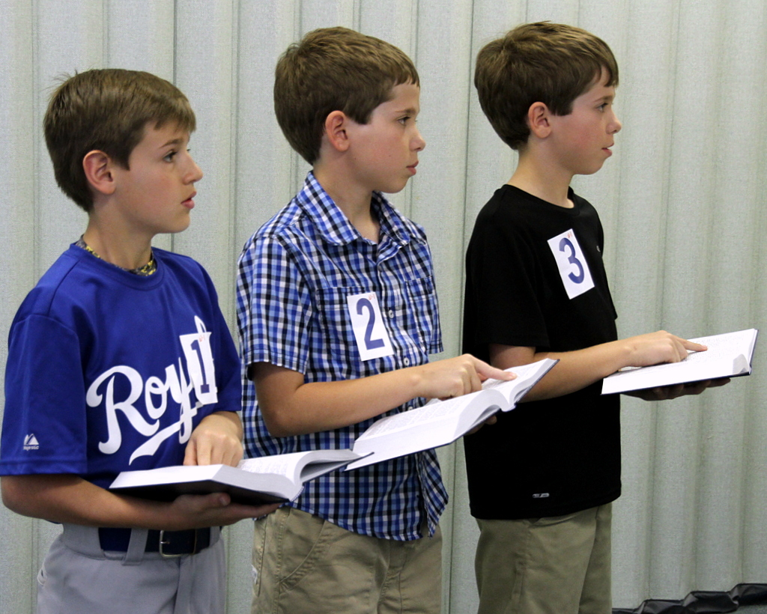
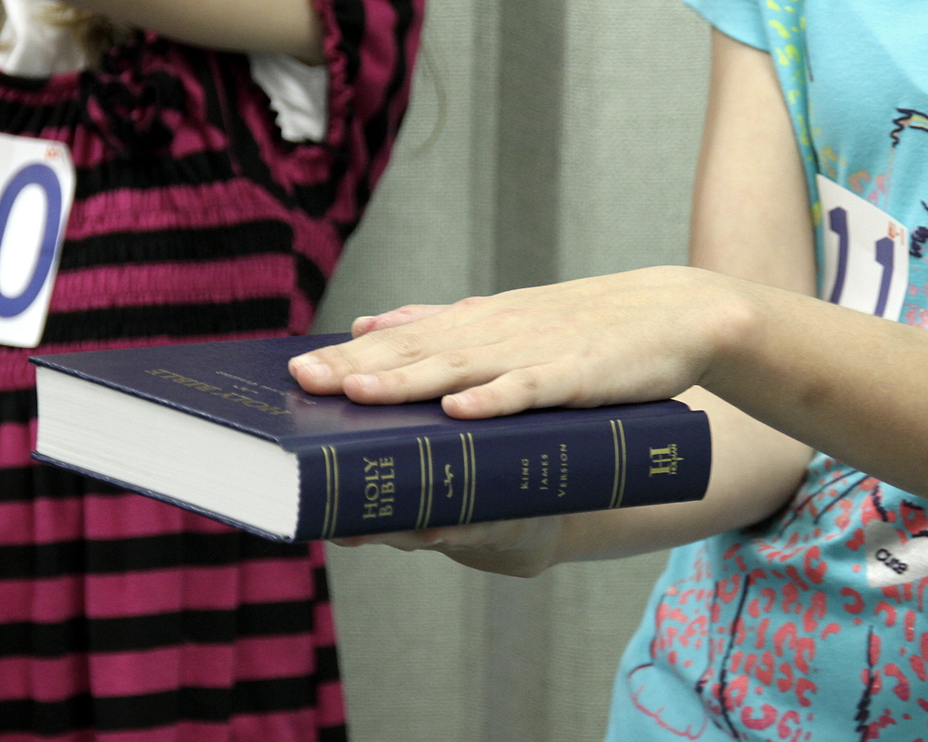
In a Socially Distanced World

4 Ways to Do Bible Drill and Teach Bible Skills
In a Socially Distanced World

Introduction
Bible Drill . . .Seconds to recall, a lifetime to remember. Bible Drill is a journey of kids and students hiding God’s Word in their hearts for a lifetime. Through Bible Drill, kids and students become familiar with God’s Word by spending time in the Bible. They memorize scripture and the 66 books of the Bible as well as learn Bible Skills. In Nothing Less: Engaging Kids in a Lifetime of Faith by Jana Magruder, LifeWay research found that the number one predictor of spiritual health as young adults is that they regularly read the Bible as kids. Bible Drill helps lay this spiritual foundation in the lives of our kids.

In the “new norm” of Covid-19, we feel Bible Drill is more important than ever. In a time of job loss, loss of the routine of school and social activities, massive life changes, sickness, isolation, and the death of friends and family, kids and students need to be reminded that God and His Word never change. They need to have God’s promises hidden in their hearts. It is a foundation for their lives now more than ever. Kids and students can recall verses like:

“He has told you, o man, what is good; and what does the Lord require of you but to do justice, and to love kindness, and to walk humbly with your God?” Micah 6:8

“Trust in the Lord forever, for the Lord God is an everlasting rock.” Isaiah 26:3

“When I am afraid, I put my trust in you.” Psalm 56:3

“I sought the Lord, and he answered me and delivered me from all my fears.” Psalm 34:4.

This eBook is a joint project between our states and is designed to help you to continue to encourage drillers in their Christian discipleship.
Maria Brannen, Georgia Baptist Bible Drill and Speakers, Inc.
Deborah Robson, North Carolina Baptist Convention
Belinda Stroud, Alabama State Board of Missions

Table of contents
At Home Page 4
Learn about resources to help keep your kids engaged in Bible Drill at home.

Be online Page 5
Develop a strategy using several of our activities to connect with your drillers online.

Church Page 9
New considerations for your Bible Drill class at church.

Discover the Outdoors Page 10
Fun Bible Drill games if your church is not meeting inside or if you want a change of pace.

Tips for Leaders Page 15
Tips for leaders to consider when planning your year of Bible Drill.

Writers Page 16
Meet our writers who have a passion for Bible Drill.

A – At Home
As Christian parents, we are to be the main disciplers of our children. However, many parents have never had this modeled for them. The Alabama Baptist State Board of Missions has developed an excellent at home resource for Bible Drill that includes a devotion for each Red Cycle Children’s Bible Drill verse as well as a fun learning activity. This resource can be used in a variety of ways:
- As a weekly family devotion resource for all of the families in your kids’ ministry
- By our families when sheltered in place whether by word of the governor of your state or by choice
- As a supplement to your weekly Bible Drill program at church or virtually
However you choose to use the resource, you will want to decide if you will post the complete resource on your website or whether you will send it out to parents monthly or weekly.
Consider providing the supplies for the activities for your families:
- In a box for the entire year: This is the most convenient option and allows families to go through the devotions at their own pace.
- In a monthly box/bag: While convenient, this allows the flexibility of regularly touching base with families/drillers through drop-offs or pick-ups.
- Weekly: This option allows the ability to adapt and change plans on a weekly basis. Example, you can send home resources with drillers if meeting at the church or do a drop-off/pick-up option if sheltering in place part of the school year.

B – Be Online
There are multiple ways we can incorporate technology into doing Bible Drill. Zoom™ has become a favorite of many churches, ministries, and families in these socially distant times. You can create a free account for Zoom™ (https://zoom.us) that allows you to use these resources for 40 minutes at a time or you can purchase a subscription if you wish to meet for a longer period of time. Zoom™ allows you to view the people (drillers) you are talking to and to interact.
Zoom™ Tips:

(1) Since we are working with minors in Bible Drill, obtain written permission from the parents for their children to log in and participate in your Bible Drill Zoom™ class.
(2) Just like in a classroom, make sure there is another adult leader on the Zoom™ call.
(3) Keep your Zoom™ time short. Do not try to meet for an hour like you do for Bible Drill Class. We recommend meeting for about 15-20 minutes.
(4) Plan multiple Zoom™ activities to do during your Zoom™ call. Vary how you do your Zoom™ call each time.
(5) Do not use Zoom™ as your only teaching/contact option for Bible Drill.

Ideas for your Zoom™ Bible Drill Time:

1. Draw a Verse:
Materials Needed: Piece of Paper, Crayons, Colored Pencils, or Markers; Bible (Translation you are Using in Bible Drill)
Do: Have the children locate the verse and read it out loud. Tell them to write the verse somewhere on the page. Discuss the verse and then ask the children to draw an illustration of the verse. (What does it mean to them or how can they apply that verse to their life?) Set a timer and give the children a certain amount of time to do their drawing. When the timer goes off allow each child to show their drawing and tell what it means to them. Then have them recite the verse again.

Recommended verses for this activity: Genesis 1:27; Leviticus 22:31; Deuteronomy 6:5; Job 37:14; Proverbs 20:11; John 15:13; 1 Corinthians 10:31; Ephesians 6:1; Philippians 4:6; James 1:19

Recommended Key Passages for this activity: The Creation; The Israelites Leave Egypt; The Baptism of Jesus; The Birth of Jesus; The Parable of the Prodigal Son; The Christian’s Armor

2. Stand Up and Move:
Materials Needed: None
Do: Have the children locate the verse and read it out loud. Instruct the children to stand up and get ready to move! Tell them you will give them several instructions and they are to follow these instructions as they recite the verse:
Hop on one foot.
Walk backward.
Jog in place.
Stand on your tiptoes.
Skip in place.
After they finish, have them all sit down and recite the verse together.

3. Put it in Motion:
Materials Needed: Bible (translation you are using in Bible Drill)
Do: Have the children locate the verse and read it out loud together. Assign three or four key words in the verse to each child on the Zoom™ call and have them create a motion for that word. Give them a few minutes and then say the verse allowing the children to teach their motion. Children can choose their favorite motion as they say the verse.

4. Scavenger Hunt:
Materials Needed: Children will search for items in their house.
Do: Share the verse, Key Passage, or book of the Bible you would like to teach during that meeting. Allow the children a few minutes to find an item in their house that describes that verse, Key Passage, or book of the Bible. The first one back wins. Have children share their item and how it describes the verse. This can be played multiple times.

5. Match Game:
Materials Needed: Project Board, Bulletin Board or White Board; Sticky Notes
Prep: Write the reference on one sticky note and the underlined portion of the verse on another sticky note. You can make as many matches as you desire for the verses you need to review. (This could also be used to review Key Passages). Cover each sticky note with another sticky note and number all of them.
Do: Allow each player to call two numbers to try and make a match. When a match is made have everyone say the verse together. Let the children take turns trying to make a match. When a match is made the sticky notes are removed and the team earns a point. The team with the most points after all the verses have been matched wins.

6. Bible Drill Kahoot:
Materials Needed: Smart Phone or Tablet/iPad.
Prep: Leader: Create a free Kahoot account. Then create a game to review verses, books, or Key Passages. Here is one free for your use: https://create.kahoot.it/share/bible-drill-red-cycle-review/462da5e3-1622-4d8e-905f-af5a7f757c67
Ask parents to download the Kahoot app on a smartphone or tablet/iPad before logging onto the Zoom™ call.
Do: After welcoming your drillers, make sure they each have the smartphone or tablet with the Kahoot app installed nearby. Leaders: You will use the screen share feature on Zoom™ to play the game. Ask all drillers to login in on Kahoot with the id displayed to play the game. Enjoy the game. See who is the winner!

7. Bible Drill Scavenger Hunt 2:
Materials Needed: Bible Drill Bibles, Optional: Pen, Paper, Box
Prep: (Optional) Write books of the Bible, verse references, or Key Passage titles on slips of paper and place in a box.
Do: Have a “Scavenger Hunt” as you give drillers clues to discover/locate books of the Bible, verses, or Key Passages. You can call them out like in Bible drill or as a game. Optional: Consider drawing “the clues” out of a box.

8. Bible Verse Battle:
Materials Needed: None; (Optional) Create a fun “Game Paddle” that kids can raise when they know the verse. You can create it and send it to the drillers or challenge them to create their own and share it when you meet.
Do: Call out a verse reference. Have kids raise their hand if they know the correct answer. Call on someone to recite the verse. Whoever correctly recites the verse gets points.

9. Zoom™ Bible Drill Game Night with Kids and parents:
Materials Needed: Prizes. Suggested Prizes: Chick-fil-A, Pizza, or Ice Cream Gift Cards
Prep: Invite parents to be a part of this Zoom™ call. Purchase gift cards.
Do: Have families compete with other Bible Drill families to see who gets the most points. Plan 3-5 Zoom™ games from our list to play with the families. Drillers and parents have to work together to get the points. You can award a prize for each game or for total number of points.

10. Have a Bible Drill practice via Zoom™:
Take about 5-10 minutes and practice drill calls.

Other Online Resources/Activities to Use with Bible Drill:

Bible Drill app – Encourage drillers/families to download the Bible Drill app from the iTunes store to review their Bible Drill verses. You can review the verses and share them by text, email, or on social media.

Memverse.com – https://www.memverse.com/ Create a free account. Choose your Bible Drill translation and enter your Bible Drill verses to memorize. Create a church leader board to challenge your drillers or other churches in your association to a friendly competition. This website will email reminders to practice.

Quizlet – Create a free Quizlet account. Create digital flash cards for review using your Bible Drill translation and the red cycle verses. Google and find Quizlet flash cards other drillers have created.

Bible Drill Videos – Challenge your drillers to have a parent record them saying the Bible verse or books of the Bible. Have parents submit the video to you as the Bible Drill leader or share on social media. Have a prize to give drillers who submit videos. Another option: Do a drawing of submitted videos for a prize.

Virtual Bible Bingo – www.bingobaker.com
Leaders or families may go to this website to make up their own bingo cards. Books of the Bible or words to a specific Bible verse may be typed in each square. Families may generate their own cards and play together, or leaders can allow drillers to develop individual cards and play on "Zoom™."

Online Bible Memory Games - https://thebible.life/online-bible-memory-games/

C - Church
Even though you may be able to meet back at church for your Bible Drill class, depending on current church, state, and CDC guidelines, you may need to keep these things in consideration for your class:
- Have hand sanitizer available.
- Space out drillers for learning activities and drilling. (Social distance whenever possible.)
- Consider meeting in a larger classroom that will make social distancing easier.
- Consider have individual learning activities rather than shared activities. (They can be hard to sanitize). Some types of learning activities that can be used individually: sets of verses, books of the Bible cards, learning activities with craft sticks, sticky notes, etc. Spend part of your class time having drillers help cut out or create activities. Store their activities in their individual bin or Ziploc© bags. Additional option: Use senior adult volunteers to cut out and help create the individual activities.
- Have individual pens, pencils, markers, etc. available for class.
- Follow cleaning guidelines after class is over.
- Be aware of church, city, or state guidelines regarding wearing masks. Will schools be requiring kids to wear masks? Watch this great video by Jeff Land at Sugar Creek Baptist in Houston that talks about kids wearing masks: https://www.youtube.com/watch?v=vckr65gC9Dk&feature=youtu.be

D – Discover the Outdoors
During this time of social distancing, meeting outdoors can provide another option for how to do Bible Drill. Depending on current church, state, and CDC guidelines, you may want to try this option. You could meet on the church campus or in the yard of a leader or driller. As long weather allows this can be an option. Consider the following:
- Altering your regular meeting time if it will mean cooler temperatures.
- Consider a shorter meeting time in order to minimize the need for a bathroom break or to go indoors. Suggested Meeting time: 30-45 minutes.
- Have hand sanitizer or handwashing stations available.
- Remember to social distance.
- Determine whether children and leaders will wear masks.
- Have everyone bring a camping chair or towel to sit on.
- Have kids wash hands/use hand sanitizer after games they play together (tossing a ball, etc.)

Outdoor Games:

1. Sparkle
Materials Needed: Poster Board, Marker
Prep: Write the memory verse on a piece of poster board.
Do: Allow everyone to read the memory verse together then make a circle with the leader or teacher standing in the middle of the circle. Choose one person to start saying the verse beginning with the first word of the verse, then continue around the circle with each person saying the next word of the verse. After the verse is completed the next person says the reference then the next person says, SPARKLE! The person next to the one who said SPARKLE must sit down. If you are sitting that means you are out of the game. This pattern continues -saying and sitting- until one person is left sitting and they are the winner.

2. Stand on a Reference
Materials Needed: Construction Paper or Card Stock and Permanent Marker; Option: Sidewalk Chalk
Prep: Write Bible Verse References on cardstock or construction paper and laminate.
Chalk option: Write references in the parking lot or sidewalk using chalk.
Do: Place or write the references around the area you have provided. Read the underlined part of the verse and let the child go stand next to the correct reference and say the entire verse. Take turns so that every child has had a chance to go stand on each reference and say the verse. You could play this with teams keeping score.

3. Three in a Row
Materials Needed: Green Paper, Red Paper, Yellow Paper, Tape, and Scissors
Option 1: Chalk; Option 2: Vinyl Tablecloth, Permanent Marker,
Prep: Option 1- Chalk: Draw a gameboard three squares by three squares
Option 2 - Tablecloth: Tape a gameboard three squares by three squares onto a vinyl tablecloth that could be used over and over.
Cut 6 circles from green paper, 6 triangles from red paper, and 6 squares from yellow paper.
Do: Divide the group into three teams. Determine who will go first. The leader reads a memory verse with a missing word and if the team can identify the missing word, they can place their shape anywhere on the board. The play continues until a team gets “Three in a Row.”

4. Water Balloon Toss
Materials needed: Water Balloons; Bin to Hold Water Balloons
Prep: Fill water balloons with water. Provide 1 balloon per 2 drillers and a few extras
Do: Have 2 drillers stand across from each other approximately 1 foot. Both drillers will take turns tossing the balloon back and forth and will try to catch it. As they toss the water balloon back and forth, they take a small step back each time. As they toss the balloon, they will say the books of the Bible or scripture verse. The last team with their balloon not popped, are the winners.

5. Memory Jump Up
Materials Needed: Bible Drill Bibles
Do: Have the children look up the verse in their Bibles and read it several times together. Children will squat in a circle and the first one will say the first word of the verse and jump up. Continue around the circle several times until the verse is learned. Then time how fast they can jump up and say the verse seeing each time if they can improve their time.

6. Basketball Games
Materials needed: Basketball or Similar-Size Ball
Basketball Dribble
Do: A child dribbles the ball, saying one word of a verse with each bounce
Basketball Bounce
Do: Have 2 drillers bounce the ball back and forth reciting the different words of the verse.

7. Football Verse toss
Materials Needed: 1 Football Per 2 Drillers
Do: Have 2 drillers toss the football back and forth reciting the different words a verse.

8. Frisbee Throw
Materials Needed: Collect 6-10 Frisbees or Large Plastic Lids; Strips of Paper (2 strips/verse); Tape
Prep: To review 3-5 memory verses - print verse references on strips of paper – two strips for each verse. Tape the strips to the Frisbees so each team has a complete set.
Do: Arrange the verses in the same order for each set. Divide children into two teams. Throw the first Frisbee in each stack. One member of each team runs to fetch a Frisbee, reads the reference, and runs to a prearranged location to say the verse.

9. Survivor Games
Materials needed: Various
Do: Create individual relay challenge games, obstacle courses, or solve large verse puzzles. Use printable book/verse cards or for extra fun, create a large wooden puzzle set for each team to solve.

10. Books of the Bible Spoons
Materials Needed: Large Blanket (or Table, Chairs); Plastic Spoons, Books of the Bible Cards
Prep: Print out or create a set of Books of the Bible cards, set up area to play spoons
For instructions on how to play spoons:
https://www.howdoyouplay.net/card-games/how-to-play-spoons.html
Do: Have drillers wash hands before they begin. Play spoons using the books of the Bible cards. Throw away the spoons after you are finished playing. Have kids wash hands afterward.

11. Outdoor Roll 6
Materials Needed: Per Driller: A Die, Clipboard (or Piece of Cardboard), Pen, Paper.
Do: Play Roll 6 to review books or a verse. Go around the group and let each person roll their die. If a driller rolls 6, they start writing out the books of the Bible or a verse you are learning. The rest of the drillers take turns trying to roll a 6. If someone rolls a 6, the previous driller quits writing. The person who just rolled 6 begins writing. Continue play until set time is up or someone completes the list of books or the verse. Option: Create more fun by obtaining inflatable dies for each driller.

12. Key Passage match
Materials: Sets of Preprinted Key Passage Titles and References; Optional: Chalk
Prep: Using your printer, print out a set of Key Passage titles and references for each driller and spread each set in random order. If using chalk, write out the Key Passage titles and references in random order in the parking lot.
Do: Have driller(s) match the titles and references. When they finish, without looking, have driller(s) recite the reference when the leader calls out the Key Passage title.

13. Verse Art
Materials: Colored Chalk – Several Sets (3 Different Colors Per Driller)
Do: Have drillers write out the verse of the week and illustrate it. You can assign each driller to a parking slot or a section of a driveway or sidewalk. After they finish, have them recite it.
14. Cup Stack
Materials: Per Driller: Set of Cups, Permanent Marker (The number of cups will depend on the verse you choose.)
Prep: set out cups and permanent marker for each driller
Do: Have drillers write the verse and reference on cups – 1 or 2 words per cup. After they finish, have them stack the cups in the correct order. Options 1: See who can stack the cups the fastest in the correct order. Option 2: Have individual relay race with stacking the cups in correct order.

15. Jump Rope Games
Materials Needed: 1 Jump Rope Per Driller
Do: Play several games with a jump rope

- Single Style: Have the child say the verse while jumping rope. See if they can make it through the entire verse without missing a beat or word.
- Challenge: See which child can say the verse the most times while jumping.
- Bunny Hop: Have each child place their jump rope on the ground in a line. Have them hop over the rope on one foot while saying the verse
- Flashback: Swing the rope in the other direction and say the verse while jumping backwards.
- Donut Jumps: Make the rope into a circle on the ground and jump into the circle then out while saying the verse.

Outdoor Games with a Swimming Pool:

1. Kickboard Books of the Bible Scavenger Hunt
Materials needed: One Kickboard Per Swimmer, Foam Noodles, Knife, Permanent Marker
Prep: Cut a noodle into 1-2-inch pieces. Write the Books of the Bible on the foam noodle pieces
Do: Take the Books of the Bible foam pieces and toss in the pool. Swimmers will use their kickboard to “swim” across the pool to find the books of the Bible, in order.
Variation: You can do just the major prophets, the gospels, or the books of law, etc. Consider making a color-coded set per swimmer and see who can find all the books and put them in order the quickest.

2. Pool Hoop-de-loop
Materials needed: 2 Pool Noodles; Duct Tape; Set of Books of the Bible (written on pieces of foam from above activity)
Prep: Make a giant foam noodle hoop by attaching the 2 pool noodles together, into the form of a circle, with duct tape.
Do: Toss the giant foam noodle into the swimming pool, then toss the books of the Bible into the hoop. Have the “swimmers” close their eyes and choose a book of the Bible, then they have to say the book before, book chosen and the book after.
Variation: Do this game with scripture verses.
Tips for Leaders

Consider the following:

Provide Drill Bibles for kids to have at home.

Give incentives to kids who participate/memorize the verse in Bible Drill on a weekly basis. Do drawings for a porch gift drop-off. Ideas - $5 Chick-fil-a gift card, Little Caesar’s Pizza delivered, favorite candy drop-off, fall – family smores kit, etc.

Making individual games and activities for kids/students because of the concern of shared supplies/activities. Some resources to have on hand that are cheap and easy for individual games: sticky notes, craft sticks, cups, etc.

If you are not meeting at the church, consider how to touch base on a weekly basis with your drillers: porch drop-offs, mailing items, Zoom™ calls, phone calls, etc.

Create a Bible Drill/skill goody bag for drive-up pick up or porch drop-off. Consider mailing some of the items.

Consider doing monthly challenges – Books of the Old Testament or New Testament, verse, Key Passage challenges. Maybe offer incentives like a prize drawing, or a small Chick-fil-A/ice cream gift card for each driller.

Hybrid approach – Do not just choose one option, consider that with the changing nature of ministry during Covid-19, you may use 2 or more of all of these options to keep in touch and to disciple your Bible Drillers during 2020-2021. We think the drillers will like the variety. Example: Zoom™ calls every other week when not meeting, porch drop-offs, challenges, back yard practices, etc.

Consider that some of your driller families may choose to stay home during the pandemic and not participate in on campus activities. If your church is meeting on campus or outdoors, provide ways to continue to connect with drillers.

Writers:
Maria Brannen serves as the Executive Director of Georgia Baptist Bible Drill and Speakers, Inc. She has given leadership to Bible Drill across the state of Georgia since 1998 (including over 20 years with the Georgia Baptist Mission Board.) She has served on the National Invitational Leadership team since 2003. Maria holds a Master of Religious Education from Southwestern Baptist Theological Seminary. She has a passion for seeing kids and families develop a love for reading the Bible, scripture memorization, and Bible Skill Development.
Email: bibledrillspeakers@gmail.com
Website: https://bibledrillandspeakers.com
Facebook: https://www.facebook.com/groups/258563451994512/
Pinterest: https://www.pinterest.com/gabibledrill/boards/

Deborah Robson currently serves as the State Bible Drill Consultant for the Baptist State Convention of North Carolina where she has served for 11 years. She also serves on the National Invitational Tournament leadership team. She earned her Master of Divinity with Religion Education from Southeastern Baptist Theological Seminary. She has a passion to help children learn God's Word in their mind and hearts. Psalm 119:11
Email: drobson@ncbaptist.org
Website: www.ncbibledrill.org
Facebook: NC Bible Drill

Belinda Stroud currently serves as a State Missionary at the Alabama Baptist State Board of Missions in the Office of Sunday School and Discipleship where she works in the areas of Childhood Education and Bible Drill. She also serves on the National Invitational Bible Drill Team. She attended Samford University where she met her husband Stephen, they have two sons, Barkley and Bentley. Please let me know if you have any issues. She enjoys teaching children and students God’s Word and equipping leaders around Alabama as they share and teach God’s Word.
Email: bstroud@alsbom.org
Website: www.kidzlinkal.org

