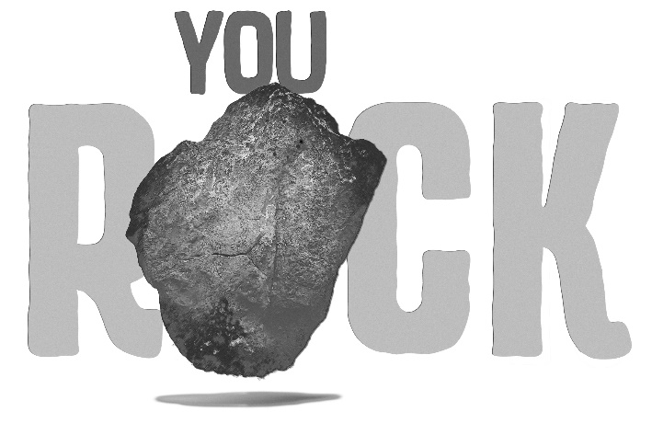

2021 Virtual Bible Drill Retreat
General Information

- You ROCK! God Loves You!
We love because he first loved us. 1 John 4:19

- God is your ROCK!
May the words of my mouth and the meditation of my heart be acceptable to you, Lord, my rock and my Redeemer. Psalm 19:4

- God can use you to ROCK the world!
“But you will receive power when the Holy Spirit has come on you, and you will be my witnesses in Jerusalem, in all Judea and Samaria, and to the end of the earth.” Acts 1:8

Theme Interpretation:
We want the drillers in your church to know that they do indeed ROCK! God loves them and will be their ROCK throughout their lives. They can also be use by the to ROCK the world by sharing Him with those with which they come into contact.

Virtual Retreat Video Conferences

Conferences can be accessed at: https://www.youtube.com/channel/UCllCCjSLZ3yOX7BVZ8v69zw

- Books of the Bible: Drillers will participate in fun activities for learning and practicing the books of the Bible.
Items Provided: Craft Sticks (10 per driller), 66 Clothespins, Markers
Items Needed: Books of the Bible Poster
- Bible Drill Procedures: Drillers will learn how to correctly handle and use God’s Word during a Bible Drill.
- Verse Completion: Drillers will learn verses…….completion style.
- Verse Quotation: Drillers will learn verses………quotation style.
- Key Passages: Drillers will have the chance to check out the Key Passages for the Red Bible Drill Cycle and learn cool ways to remember them.
Items Provided: Key Passage Concentration Game, Key Passage Posters, Key Passage Booklet (one per driller)
- Crafts: Drillers will make a candy Bible craft and a fun frisbee. They can make one frisbee for themselves and one for a friend.
Items Provided: Candy Bible Craft – (one set for each driller), three Hershey Nuggets (two for the craft and one for eating), Ribbon, Black Cardstock, Verse; Frisbee Craft – two frisbees per driller, three sharpies
- Worship: Daniel Wilson will lead the drillers in a time of worship.

